MEET & GREET SUPPORT COFFEE HOUR
Monthly, 10:00 a.m. – 11:00 a.m.
Bonds Beyond Loss

- Lenz’ Country Side Restaurant 13940 9 Mile Road, Kaleva April 10th @ 10 am
- Annie’s Kozy Kitchen 16938 Caberfae Hwy, Wellston May 1st @ 10 am
- Jennifer’s Roundabout Restaurant 4642 M-37, Mesick June 5th @ 10 am
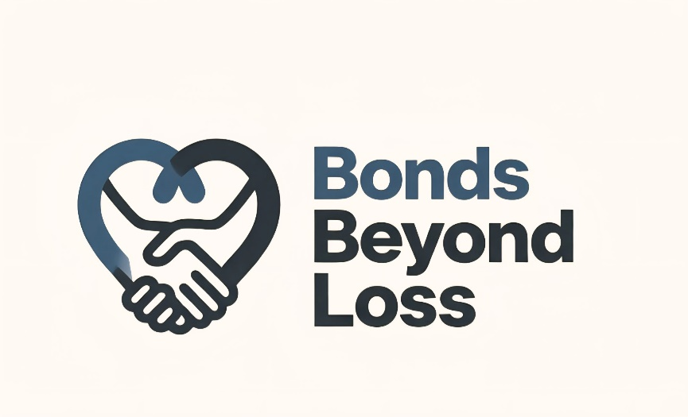
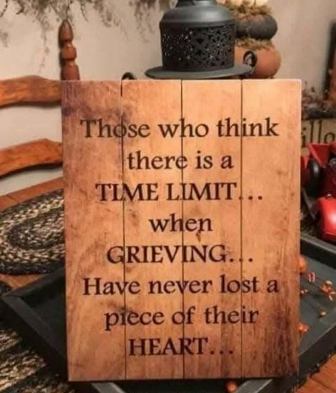
www.bondsbeyondloss.com

Facebook Private Page: Bonds Beyond Loss

Contact: Tasha Covell
231-970-1302
bondsbeyondloss@gmail.com

