BEREAVEMENT & LOSS PEER SUPPORT GROUP
Monthly, Every Second Friday of the Month, 6:00 -7:30 pm Begins April 10
Bonds Beyond Loss
Kaleva Bible Church, 8856 Osmo St., Kaleva, MI
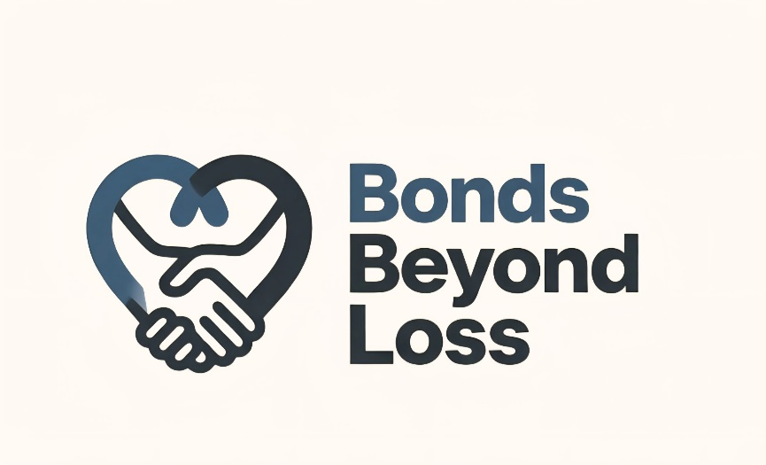
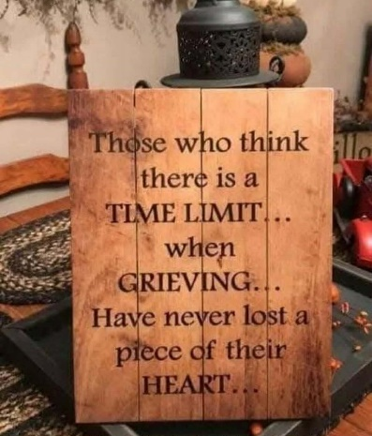

www.bondsbeyondloss.com

Facebook Private Page: Bonds Beyond Loss

Contact: Tasha Covell
231-384-5970
bondsbeyondloss@gmail.com

A compassionate group gathering experience for dealing with the emotional impact of a major loss.

Gain support from other others. Share the journey of grief and healing in a safe environment with other’s who have walked the path.

Anyone experiencing loss is welcome to attend. Find help and comfort in dealing with the passing of a loved one or friend and the challenges that can arise.

