MEET & GREET SUPPORT INFORMAL SESSIONS
Monthly, 10:00 a.m. – 11:00 a.m.
Bonds Beyond Loss
Meet up for Coffee, Discussion or Just Listen In

- Lenz’ Country Side Restaurant 13940 9 Mile Road, Kaleva April 10th @ 10 am
- Kozy Kitchen Restaurant 16938 Caberfae Hwy. Wellston May 15th @ 10 am
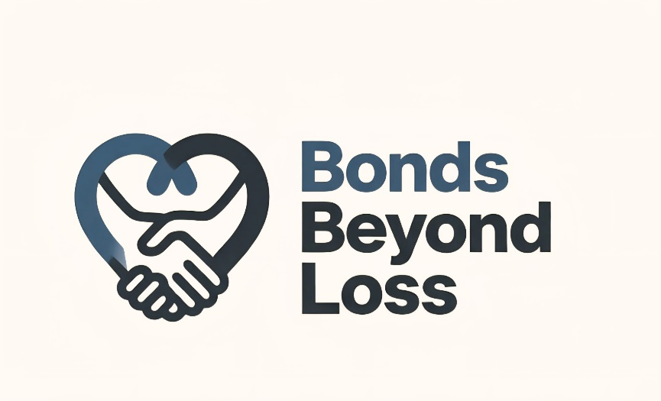
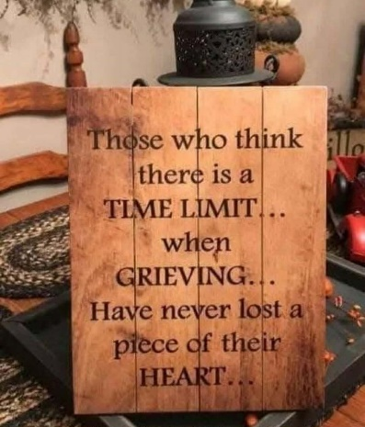
www.bondsbeyondloss.com

Facebook Private Page: Bonds Beyond Loss

Contact: Tasha Covell
231-384-5970
bondsbeyondloss@gmail.com

