MEET & GREET SUPPORT SESSIONS
Monthly, Every Second Friday of the month, 10:00 a.m. – 11:00 a.m.Begins April 10
Bonds Beyond Loss

- Lenz’ Country Side Restaurant 13940 9 Mile Road, Kaleva April 10th @ 10 am
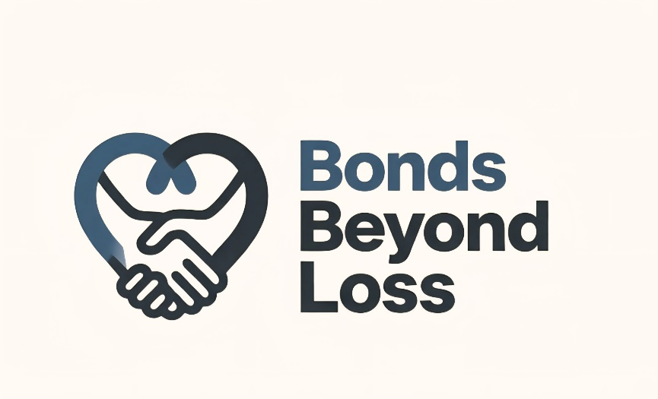
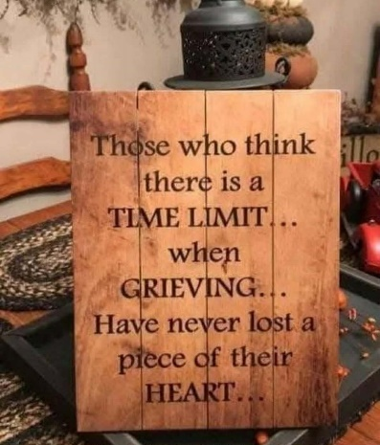
www.bondsbeyondloss.com

Facebook Private Page: Bonds Beyond Loss

Contact: Tasha Covell
231-384-5970
bondsbeyondloss@gmail.com

